

FPT UNDEFINED FLYING OBJECT
Software Requirement Specification

Project Code: FUFO
Document Code: FUFO v1.0

Ha Noi, 9th July 2012
Record of change

*A - Added M - Modified D - Deleted
Effective Date | Changed Items | A*  M, D | Change Description | New Version
04-May-2012 | Detail purpose and scope. | A* | Create newly specification | v.0.1
09-May-2012 | Functional VP | A* | Create functional VP | v.0.2
22-July | Product functions | M | Describe more detail product function | V.0.3

SIGNATURE PAGE

ORIGINATOR: Trần Thị Yến <Date>
<Position>

REVIEWERS: Vũ Minh Phong <Date>
<Position>

Lý Khôi Nguyên <Date>
<Position>

APPROVAL: Phạm Duy Hùng <Date>
<Position>
TABLE OF CONTENTS
1 Introduction 5
1.1 Purpose 5
1.2 Scope 5
1.3 Definitions, Acronyms, and Abbreviations 5
1.4 References 6
1.5 Overview 6
2 Overall Description 7
2.1 Product perspective 7
2.2 Product functions 7
2.3 User characteristics 7
2.4 Operating Environment 7
2.5 Constraints 7
2.6 Assumptions and dependencies 7
3 System Features 8
4 External Interface Requirements 9
4.1 User Interfaces 9
4.2 Hardware Interfaces 9
4.3 Software Interfaces 9
4.4 Communications Interfaces 9
5 Supporting Information 10

Introduction
The FUFO project develop commercialized Quadrocopter. It bases on Base on observation on the similar projects, a project this big may need four phases, each phase will be a relevant project to lead to the final product. This phase just focuses on the first evaluation phase.
This document describes a simple Quadrocopter which use Bluetooth & Internet protocol to communicate. After developing this phase, we can evaluation report and a Quadrocopter with basic functions that might meet customer needs.

Purpose
The SRS fully describes the external behavior of the application. This document include two main parts:
Overall description includes such items such as: product perspectives, product functions, user characteristics, constraints, assumption and dependencies. This part provides background information to make the requirements be easier to understand.

Specification requirement which provides detail information about FUFO’s system. This phase captures the complete software requirements for the system. And it gives us the most important information to project manager, designer, tester and maintainer

Scope
This project phrase focus on:
  - Make a simple Quadrocopter.
  - Use Bluetooth & Internet protocol to communicate.
  - Evaluate the application of Android Phone & PC in controlling UAV.
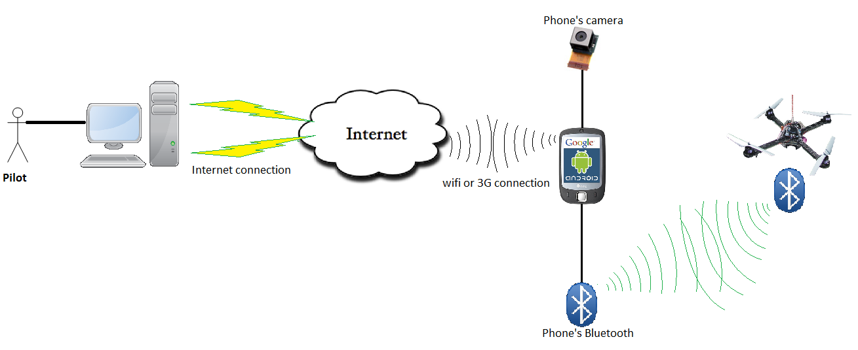

Definitions, Acronyms, and Abbreviations
Acronym | Definition | Note
PM | Project Manager
PTL | Project Technical Leader
TL | Team Leader
QA | Quality Assurance Officer
DV | Developer
SRS | Software Requirement Specification
ADD | Architecture Design Document
DDD | Detail Design Document
TP | Test Plan
TC | Test Case
SC | Source Code
AOP | Application on phone
AOC | Application on computer
FUFO | FPT University Flying Object | Controlled by AOC through AOP
PC | Personal Computer | Refer to any PC or laptop today

References
Document | Source | Note
Template Software Requirements Specification | FPT Software
Information from website: | http://www.microchip.com/

Overall Description

Product perspective
The overall product being specified in this document is the FPT University Flying Object. More importantly is the fact that this system contains an embedded system and controlling software requiring software.
This FUFO system is the result of the evaluation phase of a bigger FUFO project, which result is a Quadrocopter system that usable in security and observation purposes. The big FUFO project may need 3.5 years to finish, but this evaluation phase is only last 4 months.
Other results of this project are two study reports on the ability to hover of Quadrocopter and real-time video streaming over Internet.

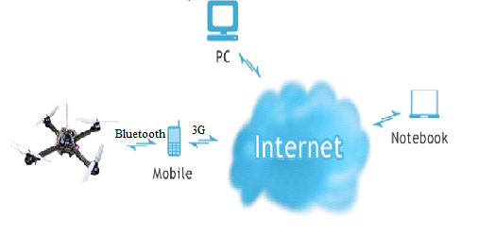

Product functions
The base aim of this phase is to make a basic Quadrocopter system that has ability to be controlled over Internet and Bluetooth via a Video Stream, as well as automatically balances itself while hovering. However, due to the shortage of time and money, the system will use an Android Smart Phone as a carrier of Video streaming and commanding over Internet.
To be specific, the functions of the system is as the following:
- The Quadrocopter:
- Can be controlled via Bluetooth by an Android Smart Phone's application (AOP).
- Can send its sensors status to the Android Smart Phone via Bluetooth.
- Can automatically keep itself balance while hovering.
- Battery system should last at least 15 minutes when the Quadrocopter does not carry any weight.
- Can carry at least 500 grams and hover at least 30 meters high.
- The Android Application:
- Receives control command from PC.
- Sends control command to Quadrocopter.
- Send video and Sensor's status to PC.
- Easy to use, maintain and update.
- The PC Application:
- Receives video and Sensor’s statuses from Android Smart Phone and display them.
- Sends control command to Android Smart Phone.
- Easy to use and good looking.
Easy to maintain and update.

User characteristics
There are two kind of user for this system, each has different characteristics:
- The development team:
- Fully understand the system.
- Focus on finding obstacles and undefined issues of the system to compare them with the advantages.
- Contains all the development team members.
- The evaluation user:
- Partially understand the system.
- Focus on finding their own experiences and feeling when use FUFO system.
- May contains anyone who is interested in the project.

Operating Environment
There are more than one meaning for the term "Environment":
- The Nature environment for the Quadrocopter to hover in:
- Both out-door and in-door environment.
- Acceptable humidity.
- Acceptable temperature.
- The Technology environment for the Communication and software of FUFO system:
- Mobile 3G network
- 100 Mbs Wi-fi network
- Any ADLS network available.
- Android 2.3 or higher.
- Windows XP and above.

Constraints
No | Description | Type
1 | Deliver one time and meet the requirement | Schedule
2 | All member of team must try one’s best, complete this work on time within 4 months | Staff
3 | The interface of Application on Phone will be friendly, easy to use and to be able to use after no more than 15 minutes. | Product
4 | Bluetooth should use version 4.0 | Product
5 | Accelerometer, Gyrocopter, Magnetometer, Barometric meter | Hardware
6 | Application on PC can run in many OS by JAVA virtual machine | Product

Assumptions and dependencies
No | Description | Type
1 | Install on Computer ( Laptop or PC) | Infrastructure
2 | Product can connect to Internet and PC. | Infrastructure
3 | Project team members are available as needed to complete project tasks and objectives. | Member

System Features
[Describe function of system, what system can do? …]

External Interface Requirements

[This section defines the interfaces that must be supported by the application. It should contain adequate specificity, protocols, ports and logical addresses, and the like, so that the software can be developed and verified against the interface requirements.]

User Interfaces
[Describe the user interfaces that are to be implemented by the software.]

Hardware Interfaces
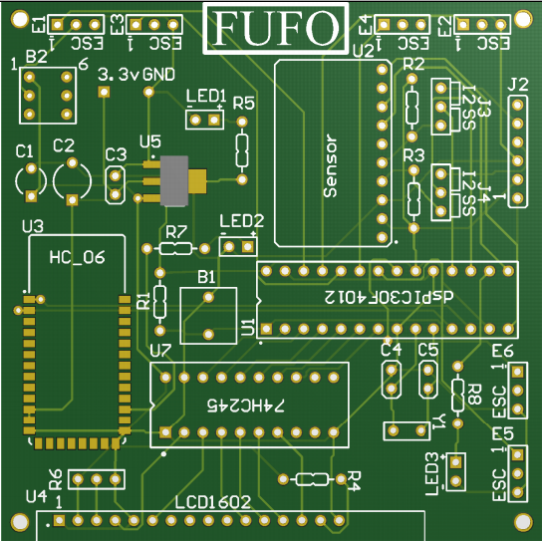

Software Interfaces
[This section describes software interfaces to other components of the software system. These may be purchased components, components reused from another application or components being developed for subsystems outside of the scope of this SRS but with which this software application must interact.]

Communications Interfaces
[Describe any communications interfaces to other systems or devices such as local area networks, remote serial devices, and so forth.]

Supporting Information
[The supporting information makes the SRS easier to use. It includes:
- Table of contents
- Index
- Appendices
These may include use-case storyboards or user-interface prototypes. When appendices are included, the SRS should explicitly state whether or not the appendices are to be considered part of the requirements.]

These are type normally: staff, budget, equipment, schedule, infrastructure, business, ...

